7.3 General support – Gender Representative
Mr. Chris HUGHES
Technical Requirements and Evaluation Matrix
Technical Requirement | Meets:  Y or N | Bidder shall complete each section below outlining how compliance is achieved and specifically reference the  information which demonstrates compliance with the criteria)
1. A University/Bachelor’s Degree in a gender related study or 3 years out of latest 10 years experience in a gender related military or civilian organization. |  | Mr. Chris HUGHES has more than 3 years in the gender related military or civilian organization. He has attended the UK MOD Human Security Advisors Course (DHSA) 2019  He had 2 years in the British Army Joint CIMIC Group (CIMIC and Human Security) working on Human Security issues on exercises including but not limited to Conflict-related sexual violence (CRSV), Gender based violence.  In addition, he had 4 years at Defence Cultural Specialist Unit working on Human Terrain analysis and including gender as a perspective through which to understand complex cultural dynamics.  Unequivocal reference evidenced by:  CV Section 4,5
2. Significant experience (i.e. in excess of 3 years in the past 10) of working at the senior levels. |  | Mr. Chris HUGHES has significant experience of working at the senior levels.  He has engaged in 3 x Ex WARFIGHTER as SME support to Cdr, briefing 2* level and conducting liaison with US Army (2015, 2017, 2019)  In addition he has 14 years experience as a commissioned officer in the British Army working in Intelligence, ISR, Info Ops and Human Terrain analysis. 11 regular and 4 reserve.  - Intermediate Command and Staff College (Land Reserve)  - Visiting Research Fellowship on Information Operations at the University of Oxford Changing Character of War Centre.  Unequivocal reference evidenced by:  CV Section 4,5  Index of supporting documents # 2,6
3. Extensive interaction with or working alongside NATO at operational level. At least 2 years within the last 10 years either as a Military Officer or  as a civilian. |  | Mr. Chris HUGHES has required experience in interaction with or working alongside NATO at operational level.  He has the following relevant engagements:  - Engaged very recently in the NATO exercise STDU 25 as the JISR CM SME.  - Trained as Cultural Advisor experienced at cross cultural communication.  - 1 year as instructor at the UN Peacekeeping center in Chile.  - Engage in Op HERRICK 19 (British support to ISAF in Afghanistan)  Unequivocal reference evidenced by:  CV Section 4,5  Index of supporting documents # 3,6
4. Current NATO Secret Security Clearance. |  | Mr. Chris HUGHES holds a NATO SECRET security clearance (valid until 2033)  Unequivocal reference evidenced by:  Index of supporting documents # 7
5. Demonstrated proficiency in English as defined in STANAG 6001 (Standardized Linguistic Profile (SLP) 3333 – Listening, Speaking, Reading, and Writing) or equivalent. |  | Mr. Chris HUGHES is a native speaker

Maj Chris HUGHES
SECTION 1: Profile

- Chris Hughes is an experienced trainer and consultant with 11 years of regular British Army service and 5 years of experience as a contractor supporting collective training and intelligence capacity building. He is also a serving Army Reservist (Major)
- He has designed and delivered courses internationally, including for the Nigerian Armed Forces and the Chilean Centre for UN Peacekeeping Operations, and supported major UK exercises in ISR, CIMIC and Media/Information Operations roles and most recently supported NATO as JISR Manager on NATO exercise STEADFAST DUEL 2025 (STDU25).
- He is qualified in ISR, Human Security, Info Ops and experienced in analysis in academic, military and corporate contexts.
- Holder of NATO SECRET security clearance (valid until 10/10/ 2033). Citizen of a NATO nation - UK
SECTION 2: Key Personal Attributes

- Analytical and dynamic trainer with a strong record of delivering complex training and advisory tasks under pressure on exercises and operations.
- Experienced in NATO and UK Defence exercise environments in a variety of staff roles.
- Deep understanding of intelligence processes, collection management, and human security within multinational contexts.
- Skilled in research, analysis and presentation; capable of converting complex intelligence requirements into actionable outputs.
- Experienced working with international organisations, including the UN and host-nation forces, fostering cooperation and trust.
- Strong communication, stakeholder management and report-writing skills.
- Experienced in EXCON, HICON and OPFOR.

SECTION 3: Relevant skills and experience

Extensive experience in intelligence training design, exercise support and ISR consultancy across NATO and partner-nation contexts:
Currently: Major (OF3), Outreach Group, (Army Special Operations Brigade) Human Security, CIMIC, Gender and Security Force Assistance expertise in support of Army exercises.
Oct 25: JWC, Contractor. Ex STDU25 JISR, Collection Manager for the NIFC/ INTEL section.
Sept - Oct 25: Jordan, Consultant. ISR Capacity building.
Aug - Sept 25: Land Warfare Centre (UK), Ex HYPERION WARRIOR (British Army Special Operations Brigade Training), OPFOR INFOWAR (Info Ops/Media)
Dec 24 - Mar 25: Nigeria, Contractor. Intelligence capacity building, designing and delivering Intelligence courses for Defence Intelligence College Abuja.
Oct 24: Germany, Contractor. Ex CERBERUS 24 (British Army Divisional training), OPFOR ISR Staff Officer.
Jun - Jul 24: UK, Student. Intermediate Command and Staff College (Land Reserve)
Nov 23: Land Warfare Center, Contractor. Ex LAND WARRIOR 23 (British Army Divisional Training), HICON CIMIC Staff Officer.
British Army Exercises and Operations at the operational and strategic level during uniformed service;
- 2022, Op SCORPIUS (British Support to Ukraine during Russian invasion)
- 2019 Ex WARFIGHTER 19.4 - US Corps Level training event
- 2017 Ex WARFIGHTER 17.5 (Ft Bragg)- US Corps Level training event
- 2015 Ex IRON RESOLVE - British Divisional Training event
- 2013-14 Op HERRICK 19 - Afghanistan

Proficient in the use of NATO Community of Interest Systems and tools such as JEMM, INTELFS.

Technical Skills - advanced MS Office user (Excel/VBA automation), familiar with ISR and intelligence software.
SECTION 4: Career Summary

Jun 2024 - Present Major (OF3), Joint CIMIC Group, (Army Special Operations Brigade)
Human Security, CIMIC, Gender and Security Force Assistance expertise in support of Army exercises.
Oct 25: Contractor - JWC, Ex STDU25. JISR Collection Manager for the INTEL section.
Managed Collection requirement responses and analysts generating simulated products for training audiences as part of the INTEL team simulating NIFC.
Sept - Oct 25: Consultant - ISR Capacity Building, ARK, Jordan
Conducted a study for the Jordanian Public Security Directorate’s Anti-Narcotics Department on how UAS can support ISR operations. Led interviews, analysis and advisory outputs to inform future capability development.
Aug - Sept 25: Contractor, Land Warfare Centre (UK), Ex HYPERION WARRIOR (British Army Special Operations Brigade Training). OPFOR INFOWAR (Info Ops)
Planned and delivered OPFOR media and information operations to generate a realistic wrap for the training audience.
Dec 24 - Mar 25: Training Contractor - Facilitator, TAG International
Delivered leadership and critical thinking training for the Nigerian Armed Forces. Designed and facilitated modules on human security, intelligence and leadership development.
Oct 24: Contractor, Germany. Ex CERBERUS 24 (British Army Divisional training), OPFOR ISR Staff Officer.
Staff Officer for OPFOR ISR conducting planning and operations for Operational level scenario to train 1(UK) Division.
Feb - Aug 23: Space Ecosystem Manager, Satellite Applications Catapult
Developed relationships across the UK Space sector, connecting industry, academia and local government to drive regional innovation.
Apr 2022 - Feb 2023: Business Management Consultant, BlackRock Alternatives
Improved business processes and technology supporting sales teams across investment asset classes. Managed multiple concurrent projects and delivered automation solutions for efficiency.
Feb 2021 - Apr 2022: Collection Manager (Russia Team Lead), UK Ministry of Defence
Managed intelligence requirements during the invasion of Ukraine. Led a team of 25 analysts, developed a VBA-based automation tool streamlining Defence Intelligence’s task management RFI-IRM-CM workflow. Also lead the departments support to UKSF..
Jan - Sept 2021: Visiting Research Fellow, Changing Character of War Centre, University of Oxford
Conducted independent research into Venezuelan state information operations. Produced analysis integrating social media data, interviews and academic literature.
Jun - Oct 2020: Training Officer, British Army
Planned and delivered training for mobile COVID-19 testing teams, managing scheduling and field operations.
Jun 2019 - Mar 2021: Project Officer, UKSF (Reserves)
Worked part time on a human terrain project with a reserve unit of UKSF.
Apr 2017 - Dec 2019: Political Advisor for Latin America, British Army
Advised on political and military affairs across Latin America. Contributed to high-profile operations and represented the UK in defence diplomacy initiatives. Concurrently worked as lead human terrain analyst (Cultural Specialist) managing a team of analysts, QCing and contributing to products and writing reports.
Apr 2016 - Apr 2017: UN Peacekeeping Instructor / Assistant Defence Attaché, British Embassy, Chile
Delivered UN peacekeeping courses, lectures and field training. Represented the UK in regional defence forums.
Apr 2012 - Jun 2015: Operations Manager / ISR Team Leader, British Army
Directed 30+ ISR project teams from eight nations collecting intelligence in Afghanistan. Managed operations, training and personnel development for a 33-person team. Wrote and contributed to IMINT products.

SECTION 5: Education and Personal Development/Certifications

- Security Force Assistance Planners course, British Army, 2025
- Cultural Property Protection Course, British Army, 2024
- Intermediate Command and Staff Course, UK Ministry of Defence, 2024
- Defence Human Security Course, UK Ministry of Defence, 2019
- OSINT Course, British Army, 2019
- Cultural Specialist Course, UK Ministry of Defence, 2017
- Spanish Language course, UK Ministry of Defence, 2015-16
- ISTAR Manager’s Course, British Army, 2013
- Commissioning Course 111, Royal Military Academy Sandhurst, 2011
- BSc (hons) Neuroscience, University of Edinburgh, 2009

SECTION 6: LANGUAGE SKILLS

English native speaker, Spanish B2, French B1
SECTION 7: Awards

Operational Service Medal Afghanistan (2013)
Joint Commander’s Commendation for service on Op HERRICK (Afghanistan)

INDEX OF SUPPORTING DOCUMENTS for Maj Chris Hughes
# | DOCUMENTS NAME/SUBJECT
1 | Batchelor of Science Degree certificate
2 | Intermediate Command & Staff Course certificate
3 | STDU 25 certificate of appreciation
4 | CCW website link
5 | UN Peacekeeping Centre CECOPAC certificate
6 | MOD 90 ID Card (Army ID)
7 | NATO SECRET clearance certificate

Index No 1

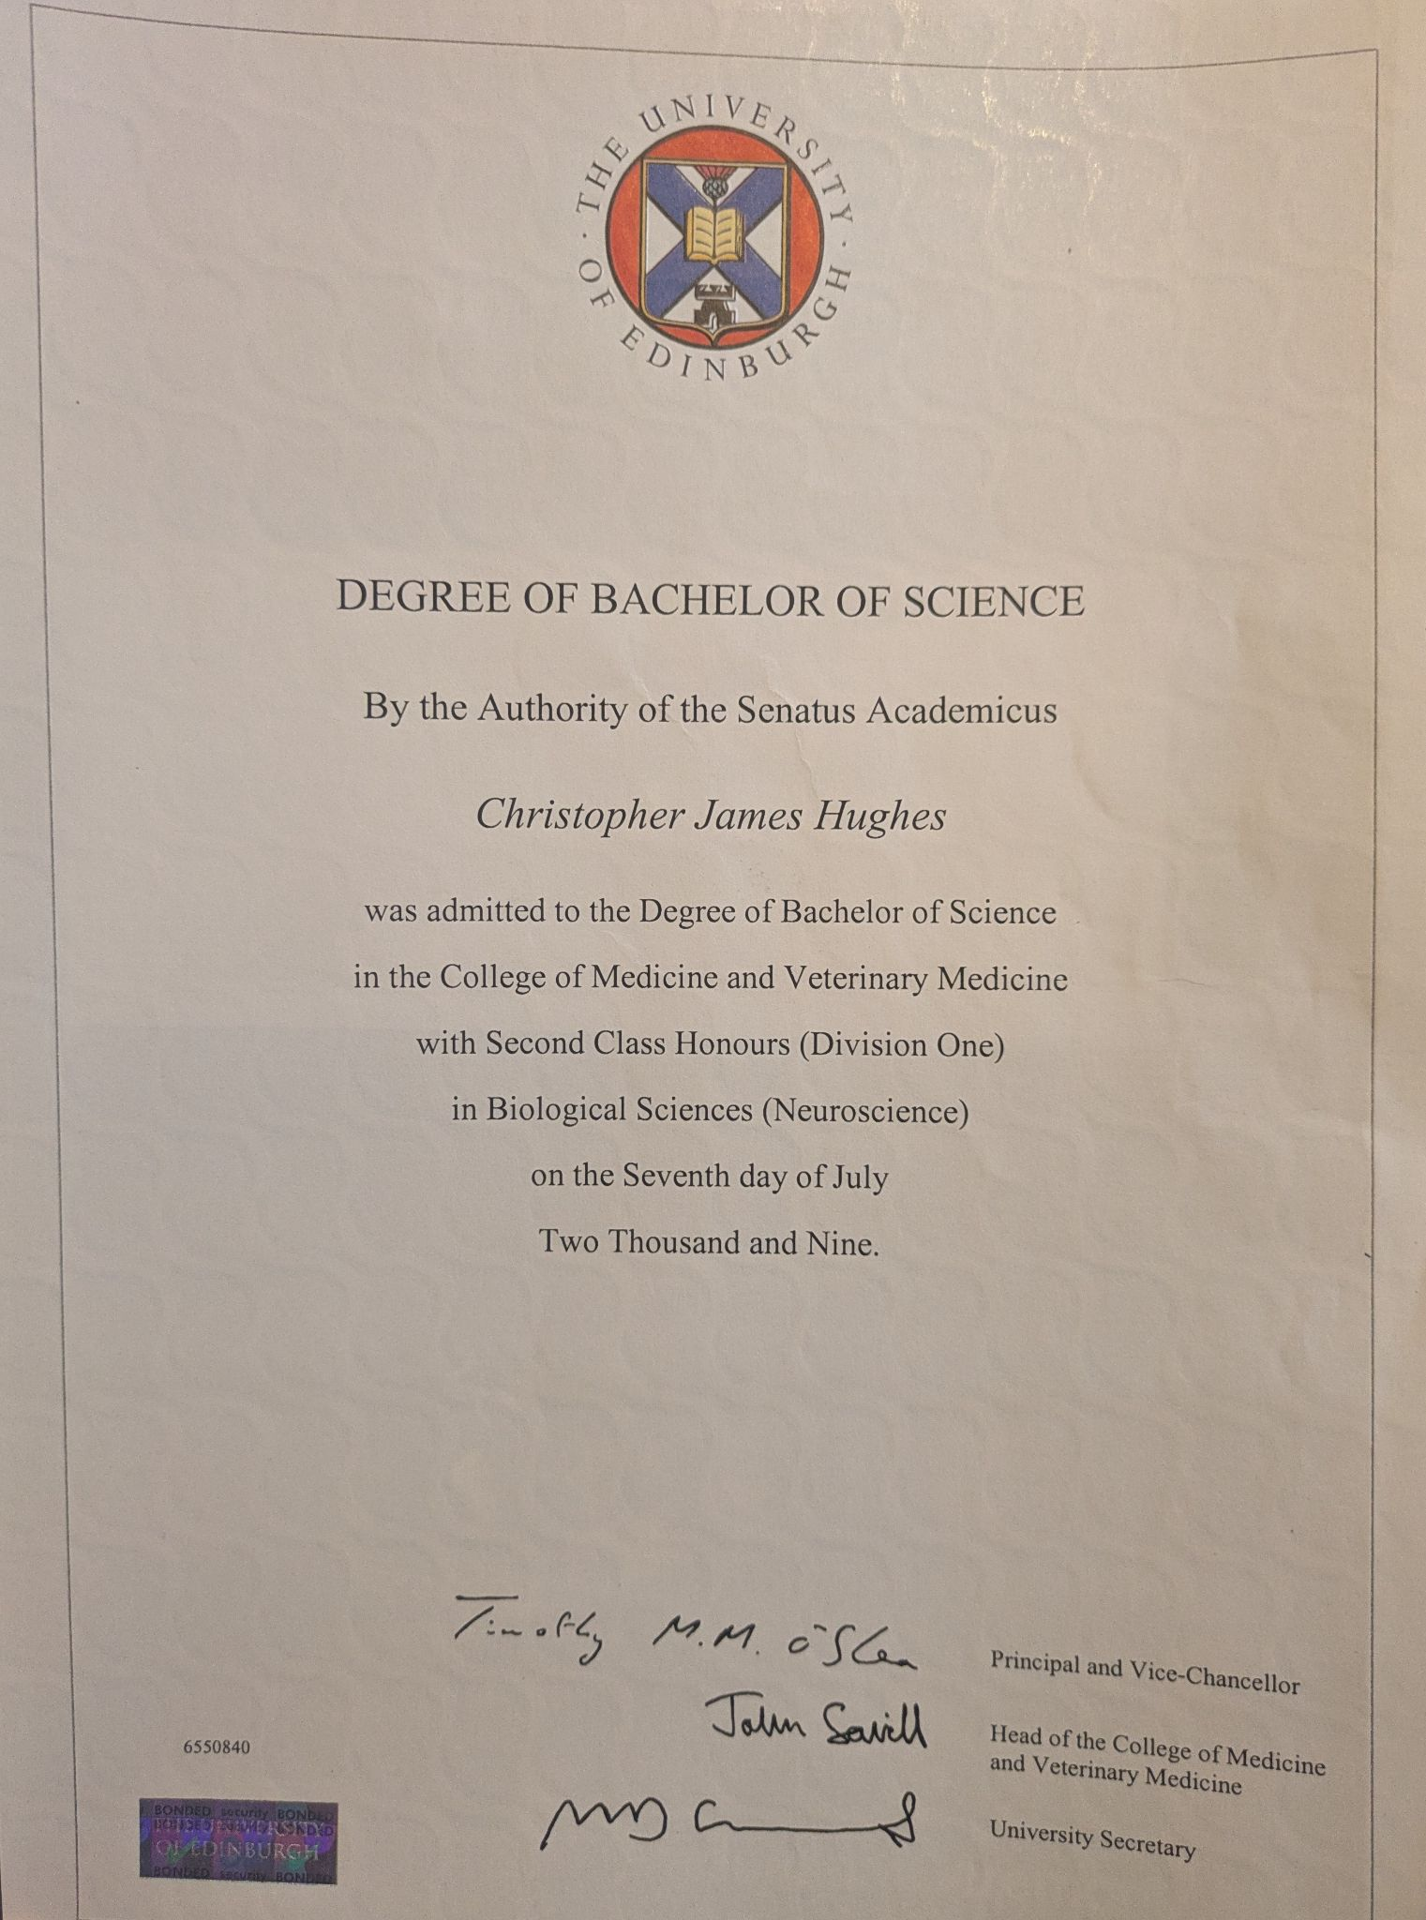

Index No 2

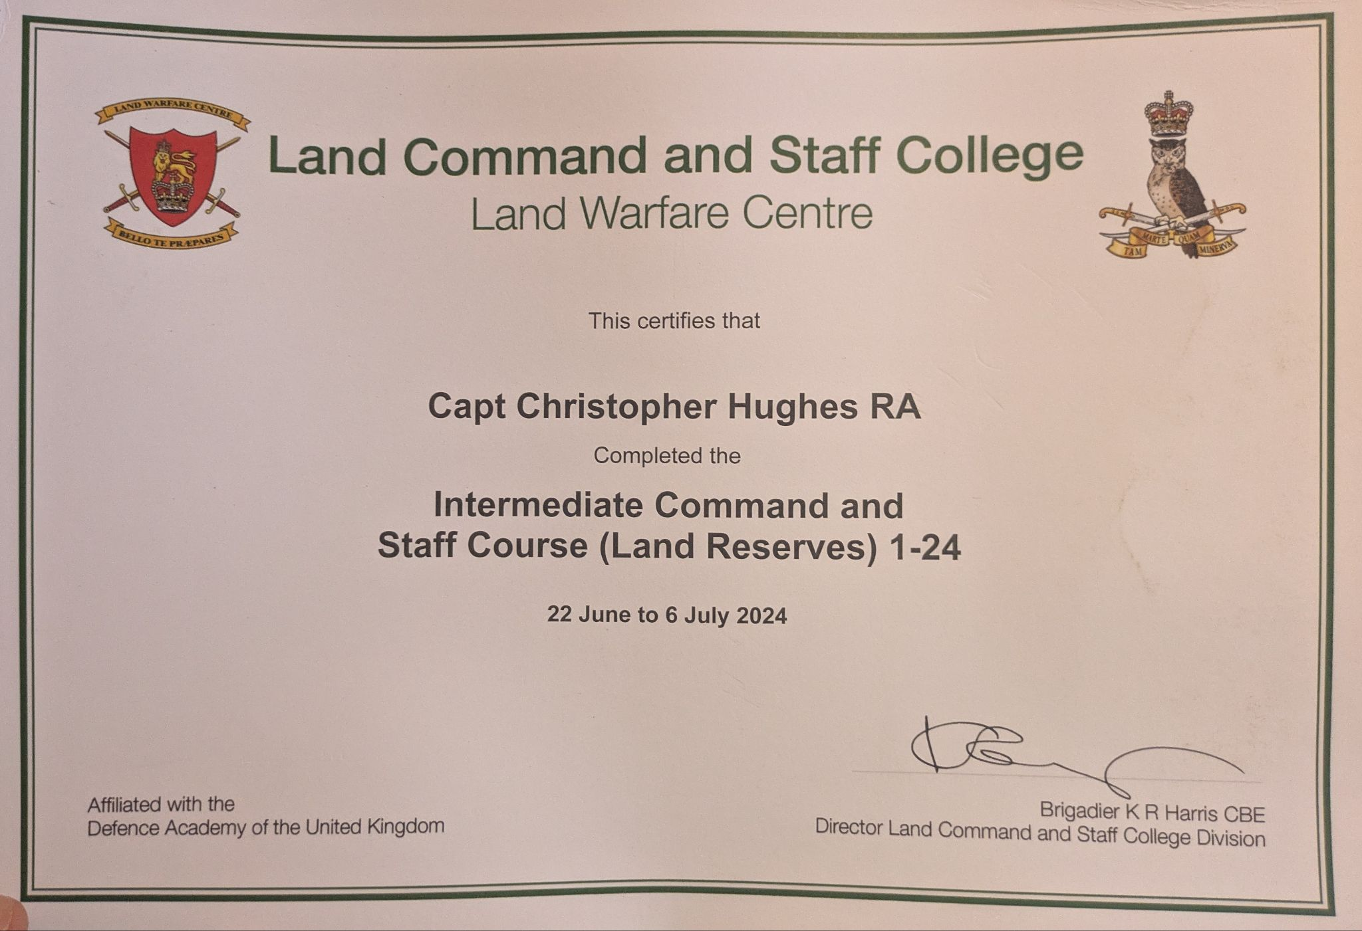
Index No 3

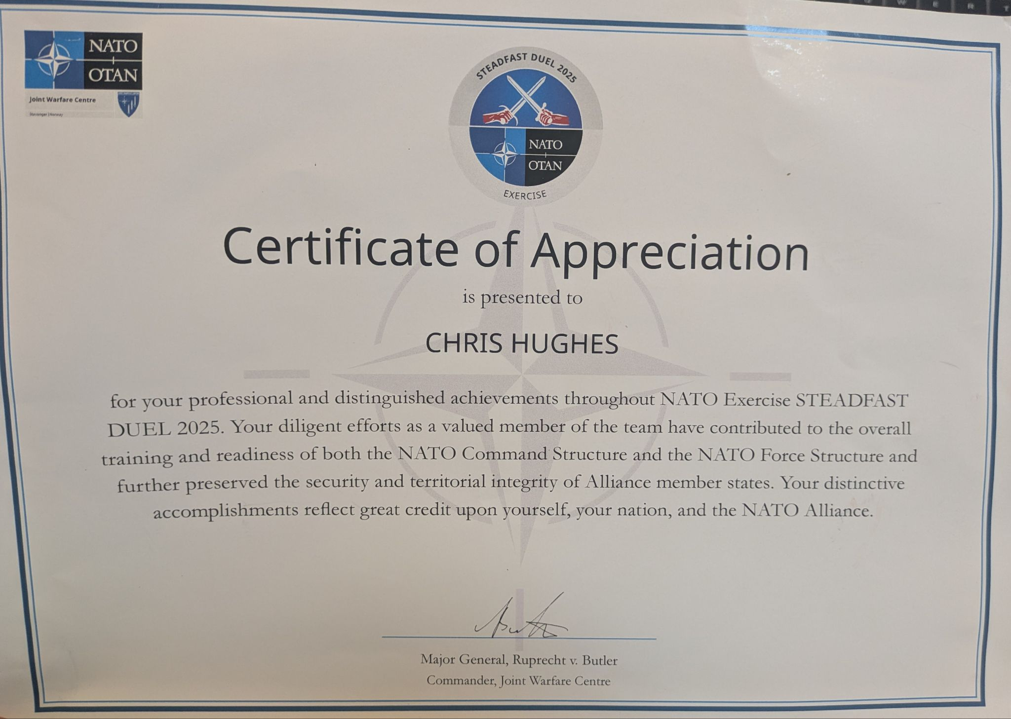

Index No 4

https://www.ccw.ox.ac.uk/visiting-fellows-1

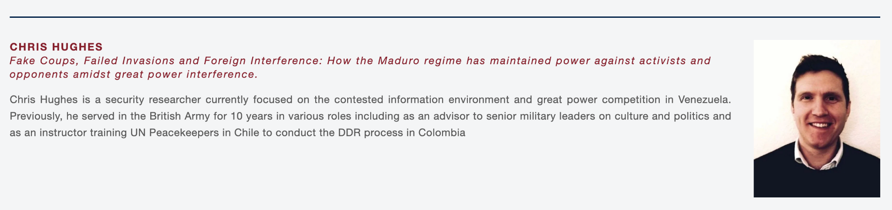

Index No 5

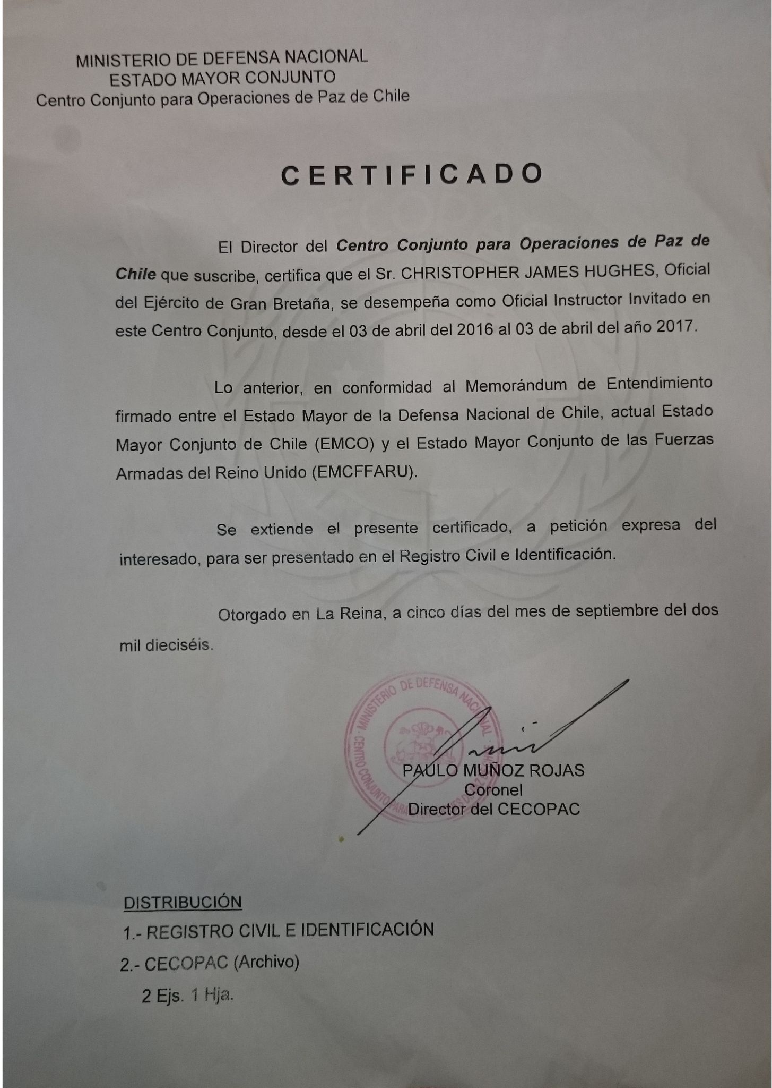
Index No 6

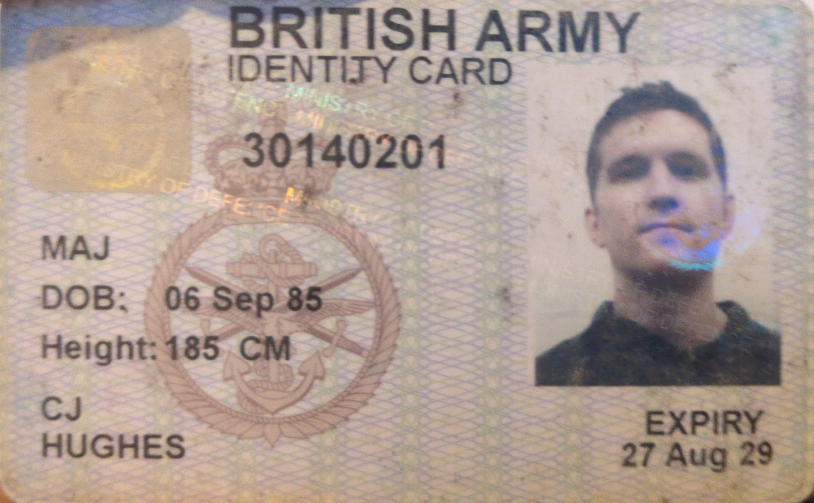

Index No 7

